

<<Project name>>
Software Requirement Document
Report 2 - Overall Description

– HoChiMinh, August 2022 –
Table of Contents
Record of Changes 3
II. Overall Description 4
1. Product Overview 4
2. Business Process 5

Record of Changes
Date | A*  M, D | In charge | Change Description
*A - Added M - Modified D - Deleted

II. Overall Description

1. Product Overview
[Content part 1: presents a high-level overview of the product and the environment in which it will be used, the users, and known constraints, assumptions, and dependencies]
[Content part 2: describes the product's context in the form of a context diagram in which you present the boundary and connections between the system you’re developing and everything else in the universe. This identifies external entities (or terminators – software, hardware, human components, and other systems) outside the system that interface to it in some way, as well as data, control, and material flows between the terminators and the system]
<<Sample: The Cafeteria Ordering System is a new software system that replaces the current manual and telephone processes for ordering and picking up meals in the Process Impact cafeteria. The system is expected to evolve over several releases, ultimately connecting to the Internet ordering services for several local restaurants and to credit and debit card authorization services.
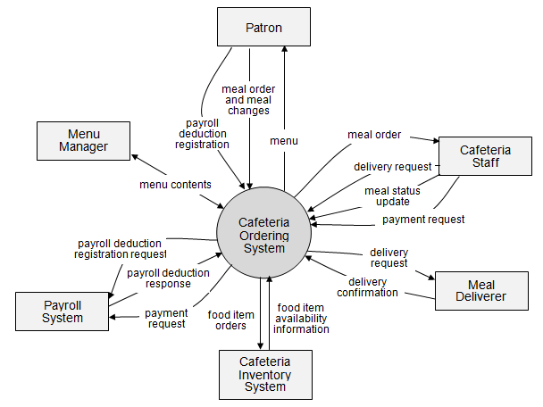>>

2. Business Process
[This part shows business processes of the system, using swimlane diagram]
<<Sample: shows a partial swimlane diagram for the CTS. The swimlanes in this example are roles or departments, showing which group executes each step in the business process to order a chemical from a vendor.
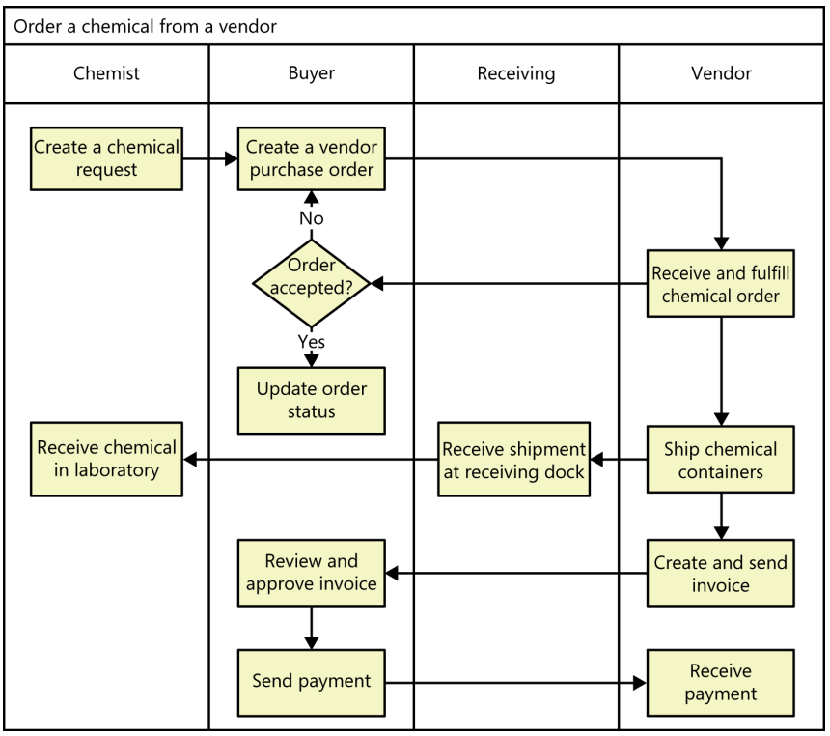
# | Process Step | Description
1 | Create a chemical request | <<Process Step description>>
2 | Create a vendor purchase order
3 | …
>>

